UNIVERSITY OF ENGINEERING AND TECHNOLOGY, PESHAWAR
Department of Computer Science
DATA STRUCTURE LAB
LAB TASK 6
Singly Linked List: Insertion at Start, End, and Before a Target Value
Submitted By: | Anas Khan
Registration No.: | 25PWCS1691
Section: | B
Semester: | 2nd
Department: | Computer Science
Submitted To: | Sir Mudasir
Date: | 21 October 2026

1. Task Statement
Write one C++ program for a singly linked list that supports three insertion operations:
- insertAtStart(head, value) inserts a new node at the beginning of the list.
- insertAtEnd(head, value) inserts a new node at the end of the list.
- insertAtAny(head, value, position) inserts a new node before the first node whose data equals position.
The program also includes displayList(head), which prints all node values from head to NULL. It must run the required test sequence and produce the final list 5 10 15 20 30.

2. Program

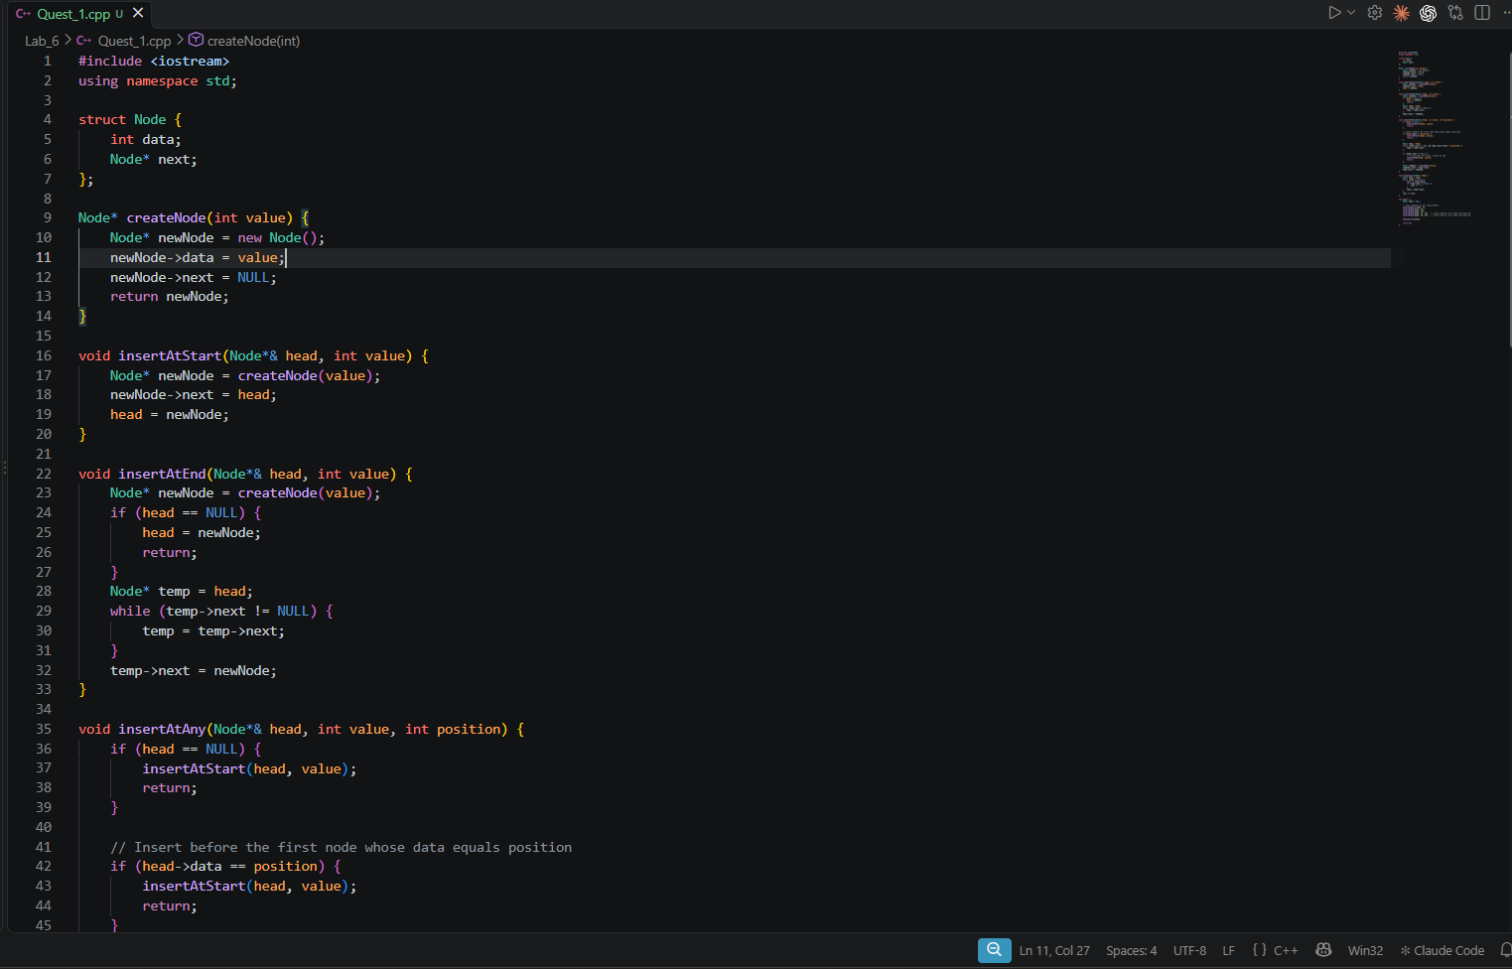

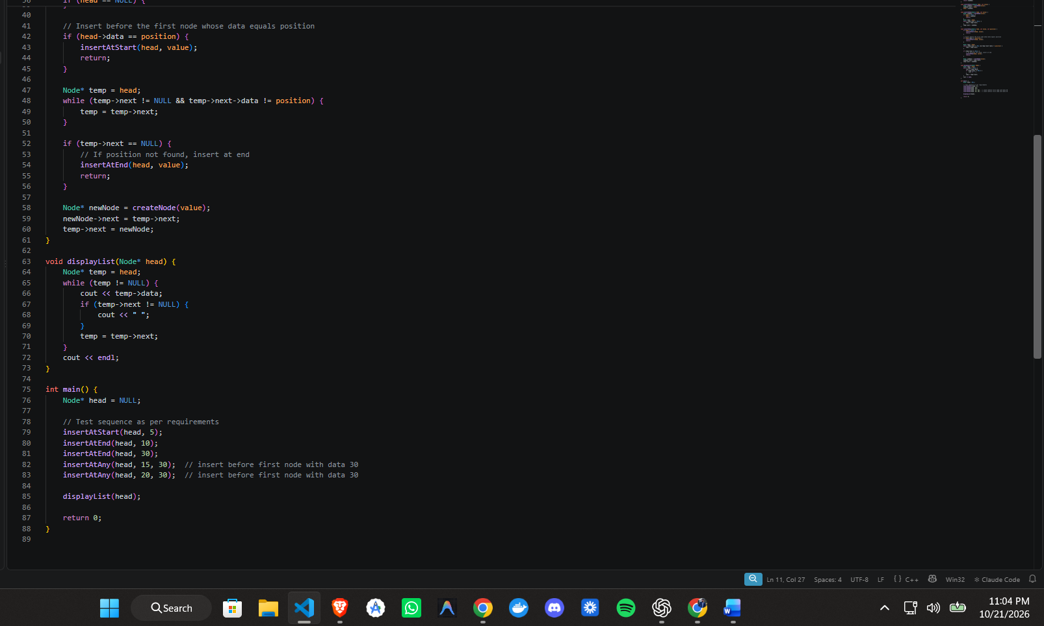

Screenshot

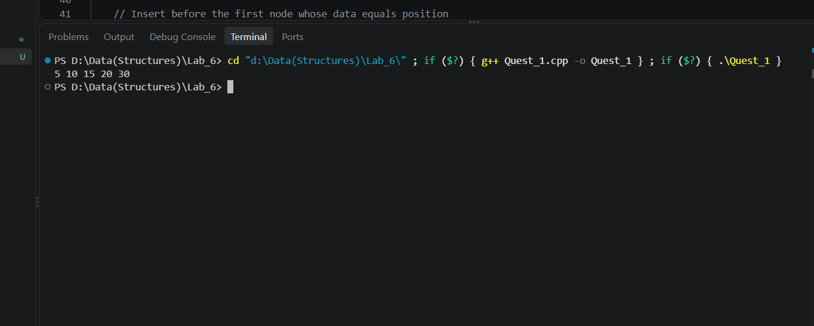

4. Trace

Test Sequence
Step | Operation | List after step
1 | insertAtEnd(head, 10) | 10
2 | insertAtEnd(head, 20) | 10 20
3 | insertAtStart(head, 5) | 5 10 20
4 | insertAtAny(head, 15, 20) | 5 10 15 20
5 | insertAtEnd(head, 30) | 5 10 15 20 30
6 | displayList(head) | 5 10 15 20 30

After Step 3: Where does head point?
head points to the node containing 5. The new node was linked to the old head (10), and then head was moved to the new node.
head -> [5|*] -> [10|*] -> [20|NULL]

During Step 4: insertAtAny(head, 15, 20)
- New node = 15
- Target node = 20
- current stops at node 10, because current->next->data == 20

Before:
head -> [5|*] -> [10|*] -> [20|*] -> NULL
^ ^
current target (20)

Step | Action | Result
1 | head->data (5) != 20, so current = head | current = 5
2 | current->next->data is 10, not 20, move forward | current = 10
3 | current->next->data is 20, match found, stop | current = 10
4 | newNode->next = current->next | 15 points to 20
5 | current->next = newNode | 10 points to 15

After:
head -> [5|*] -> [10|*] -> [15|*] -> [20|*] -> NULL
^
new node

During Step 5: insertAtEnd(head, 30)
List before: 5 -> 10 -> 15 -> 20 -> NULL
Move | current | current->next != nullptr ?
Start | 5 | Yes, move on
1 | 10 | Yes, move on
2 | 15 | Yes, move on
3 | 20 | No (20->next is NULL), stop

Then current->next = newNode links 20 to 30.
head -> [5] -> [10] -> [15] -> [20] -> [30] -> NULL

